F A S T

**File Acquisition and Signal Processing Toolkit for GNSS**

written by

Email:

Last modified: Nov 16, 2024



**WuHan University**

Contents

Introduction 3

Installation 3

Translate 3

Download 5

Parameters 5

Running Example 6

Analyze 7

Options 7

Running Example 8

SPP 10

Site Select 11

Boot Download Mode 12

Terminal Input Mode 14

Contact us 15

# Introduction

Aiming at the problems of cumbersome steps and slow download speed of GNSS data, a relatively complete set of integrated multi-source data download terminal software fast is developed.

The software contains most of the data sources required in the process of GNSS scientific research and learning. The way of parallel download greatly improves the efficiency of download.

The main features of the software are as follows:

1.**Multi platform**: Support both windows and Linux systems;

2.**Bilingual**: supporting switch between Chinese and English languages

3.**Abundant Resources**: It basically includes the data sources required in GNSS scientific research and learning. At present, it supports 15 categories and more than 100 subcategories.

4.**Fast**: The software adopts parallel download mode, and the number of download threads can be specified in the command line parameter operation mode. After testing, it only takes 48.93s to download the 100 days BRDC+IGS+CLK file!

5.**Easy to expand**: If you need to support more data sources, you can specify the required data and data sources in FTP_Source.py and GNSS_TYPE.py;

6.**Easy to run**: The software interface is designed to be simple and intuitive, allowing users to easily find the functions and options they need. The program can also be downloaded in two ways: boot download mode and terminal input mode with parameters. Run the program directly to enter the boot download mode. Run `FAST -h` on the terminal with parameters to view the introduction of operation mode with parameters;

7.**Flexible**: In the operation mode with parameters, users can flexibly specify the download type, download location, download time, whether to decompress, number of threads, etc., and can write scripts such as bat, shell and python to run according to their own needs;

# Installation

The software supports both Windows and Linux platforms, features a user interface, and accommodates both **Boot Download Mode** and **Terminal input Mode**.

**Windows**:you only need to unzip the package to run directly, enter `FAST.exe -h` can view the introduction of operation mode with parameters;

**Linux** :you only need to unzip the package to run directly: After installation, as under Windows system, you can directly run the program or configure the program to environment variables.

# Translate

On the **Download** interface, the left side is the time conversion window, which allows for quick conversion between different types of time, as below:

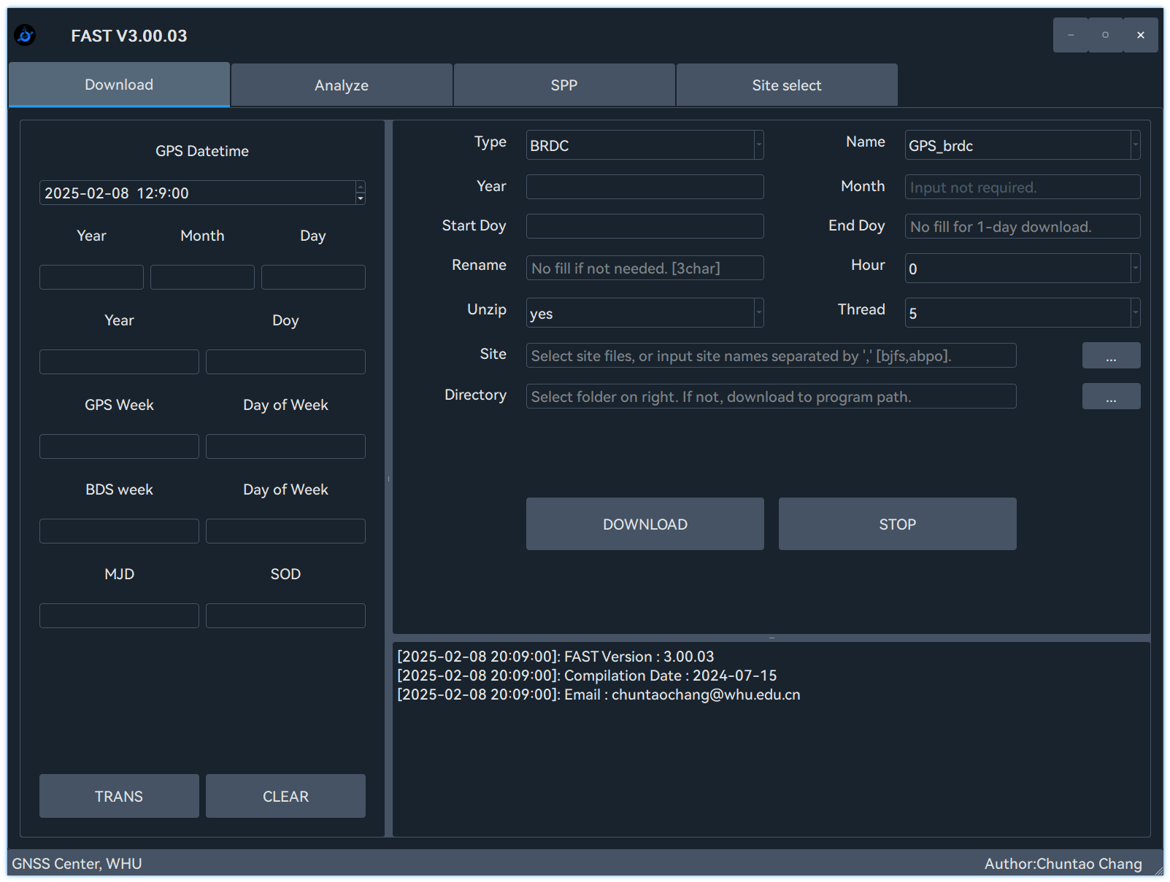

Figure 1 Download interface

The window includes the following time types:

**GPS datetime;**

**Year-Month-Day;**

**Year-Day of Year(DOY);**

**GPS Week-Day of Week;**